**Windows Functions**

1. What is SQL Aggregate Function

-- An aggregate function performs calculation on a set of values to return a single value.

-- Aggregate functions are usually used with the GROUP BY clause of the SELECT statement.

-- HAVING clause is used to write conditions on the value that is returned by the aggregate function.

-- Aggregate functions return the same value each time that it is called with a specific set of input values on same dataset.

-- For example,

**-- Fetch total salary distribution for each department**

SELECT

dept.department_name, SUM(emp.salary) as total_salary

FROM

dev_schema.employee as emp INNER JOIN dev_schema.department as dept

ON emp.fk_department_id = dept.department_id

GROUP BY dept.department_name ORDER BY total_salary DESC;

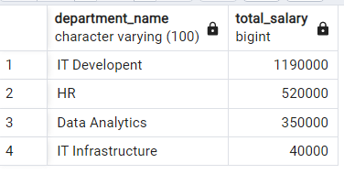

-- The above example is to get sum of salaries by each department. It uses a simple aggregate function which is sum(salary) output by single column grouping.

-- We can add multiple columns in the select statement as long as those columns are included in the group by clause as shown below.

**-- Fetch total salary distribution for each department along with the department id**

SELECT

dept.department_name, dept.department_id, SUM(emp.salary) as total_salary

FROM

dev_schema.employee as emp INNER JOIN dev_schema.department as dept

ON emp.fk_department_id = dept.department_id

GROUP BY dept.department_name, dept.department_id ORDER BY total_salary DESC;

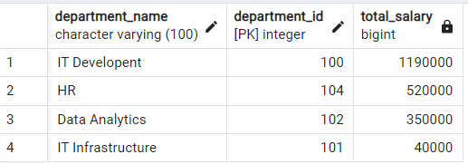

-- The above query uses two field for grouping the data and for each group the query return a single row as the result.

-- If we try to select other columns that are not in the group by clause, the aggregate function query will give error.

**-- Fetch total salary distribution for each department along with the department id**

SELECT

dept.department_name, dept.department_id, SUM(emp.salary) as total_salary

FROM

dev_schema.employee as emp INNER JOIN dev_schema.department as dept

ON emp.fk_department_id = dept.department_id

GROUP BY dept.department_name ORDER BY total_salary DESC;

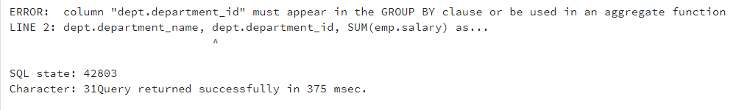

-- Here the Aggregate functions worked on a set of rows to return a single result value. If we need only a high-level summary on the data the aggregate functions are useful.

1. What is SQL Window Function

-- The SQL Window Function calculates an aggregate value based on a group of table records called window frame and return multiple rows for each group.

-- FROM clause in the Query filters the data and those virtual table data are considered in a window function for operations.

-- Multiple window functions can slice up the data in different ways by using OVER clauses.

-- We can specify the window frame partition by using PARTITION BY clauses.

-- When we have the OVER clause with an empty parameter, it will operate on the whole set of rows.

-- Below example does calculations sum, average, min, max and percentage using the whole set of rows:

**-- Using empty over()**

SELECT

salary,

SUM(salary) over() as total_salary,

AVG(salary) over() as avg_salary,

MAX(salary) over() as max_salary,

MIN(salary) over() as min_salary,

(salary::numeric/sum(salary) over()) * 100 as percentage_salary

FROM

dev_schema.employee ORDER BY total_salary DESC;

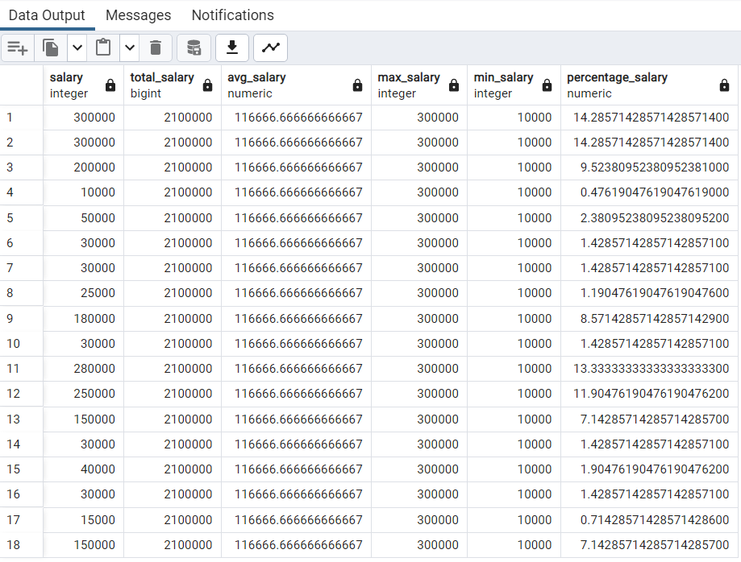

-- When we expand the above example by adding PARTITION in the OVER clause, we reduce the window frame for the column value group specified in the PARTITION column.

-- Below example does calculations sum, average, min, max and percentage for a set of window frame for each department partition.

-- We can add running total of sales in the above example by adding ORDER BY clause in the window frame.

-- It orders the rows within a window frame partition.

-- Using partition clause with over()

SELECT

dept.department_name,

emp.salary,

SUM(emp.salary) over(PARTITION BY dept.department_id ORDER BY emp.salary DESC) as total_salary_as_per_department,

AVG(emp.salary) over(PARTITION BY dept.department_id) as avg_salary_as_per_department,

MAX(emp.salary) over(PARTITION BY dept.department_id) as max_salary_as_per_department,

MIN(emp.salary) over(PARTITION BY dept.department_id) as min_salary_as_per_department,

(emp.salary::numeric/sum(emp.salary) over(PARTITION BY dept.department_id)) * 100 as percentage_salary_as_per_department

FROM

dev_schema.employee as emp INNER JOIN dev_schema.department as dept

ON emp.fk_department_id = dept.department_id;

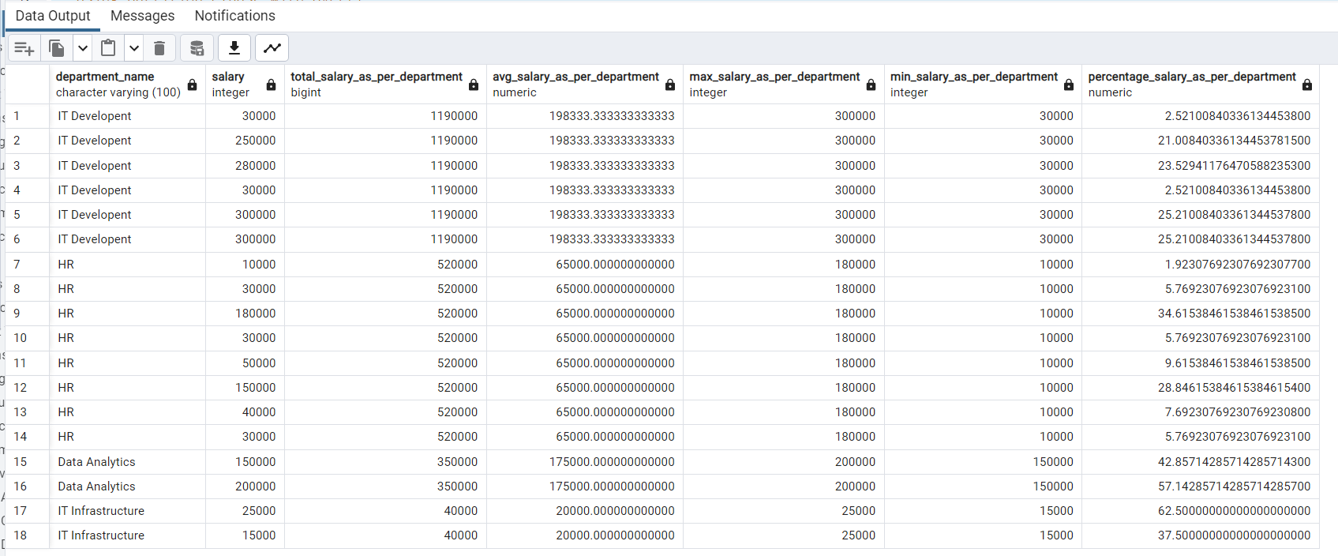

**-- Write a sql query to fetch employee id, employee name, employee salary, employee department name, employee job title, And max salary as per the department.**

SELECT emp.employee_id, emp.first_name, emp.last_name, emp.salary, dept.department_name, job.job_title,

MAX(emp.salary) OVER (PARTITION BY dept.department_id ORDER BY emp.salary DESC) AS max_salary_per_department

FROM

dev_schema.employee as emp INNER JOIN dev_schema.department as dept

ON emp.fk_department_id = dept.department_id

INNER JOIN dev_schema.job as job

ON emp.fk_job_id = job.job_id;

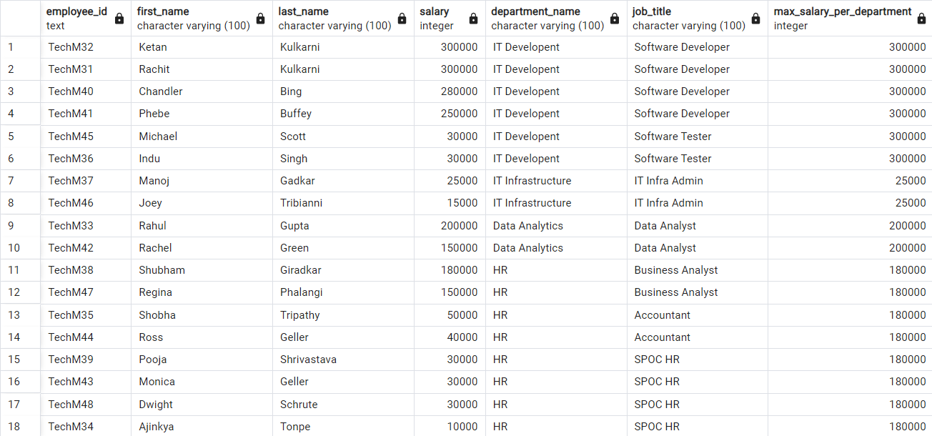

**-- Write a sql query to fetch employee id, employee name, employee salary, employee department name, employee job title, And max salary as per the department along with the count of employees per department**

SELECT emp.employee_id, emp.first_name, emp.last_name, emp.salary, dept.department_name, job.job_title,

MAX(emp.salary) OVER (PARTITION BY dept.department_id ORDER BY emp.salary DESC) AS max_salary_per_department,

COUNT(*) OVER (PARTITION BY dept.department_id) as total_no_of_emp_per_dept

FROM

dev_schema.employee as emp INNER JOIN dev_schema.department as dept

ON emp.fk_department_id = dept.department_id

INNER JOIN dev_schema.job as job

ON emp.fk_job_id = job.job_id;

